This folder includes all the measured values from Arduino IDE.

###################

**“measurement – photoresistor.xlsx” file** includes the values from photometer and Arduino IDE when calibrating a normal display.

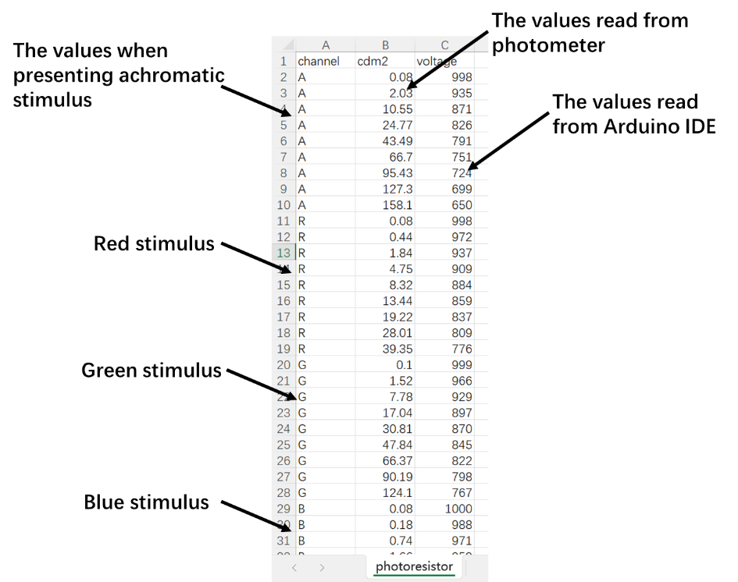

###################

**“measurement – raw.xlsx” file** is the file where we obtained the raw values directly from Arduino IDE when calibrating a VR display.

**“measurement - raw - convert to luminance.xlsx” file** is the file where we converted the values from Arduino IDE into luminance (in cd/m2) based on the response property calculated from “measurement – photoresistor.xlsx” file.

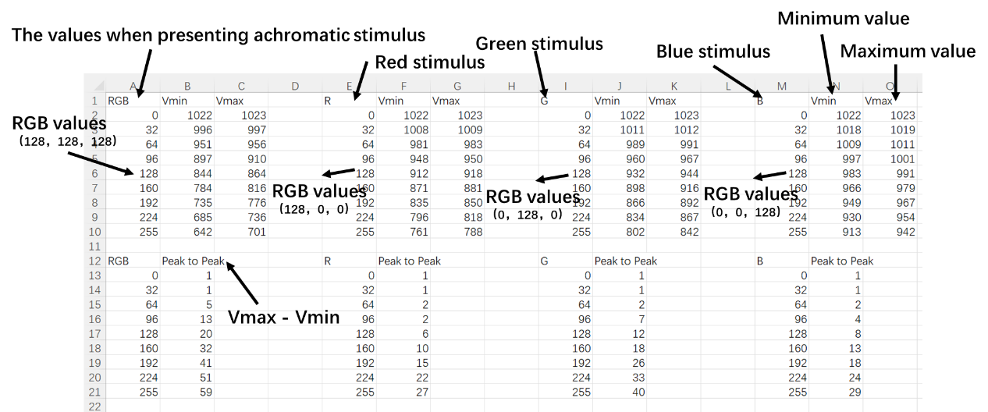

**“VR_left_gamma_uncalibrated” sheet** means: the left eye VR display was measured;

the color space was set to “Gamma” mode; the value was measured before calibration.

**“VR_left_gamma_identically_calib” sheet** means: the left eye VR display was measured;

the color space was set to “Gamma” mode; the value was measured after calibration, and the calibration was based on presenting achromatic stimulus (RGB channels simultaneously).

**“VR_left_gamma_separately_calib” sheet means**: the left eye VR display was measured;

the color space was set to “Gamma” mode; the value was measured after calibration, and the calibration was based on presenting chromatic stimulus (R, G, and B channels separately).

**“VR_left_linear_uncalibrated” sheet** means: the left eye VR display was measured;

the color space was set to “Linear” mode; the value was measured before calibration.

**“VR_left_linear_separately_calib” sheet** means: the left eye VR display was measured;

the color space was set to “Linear” mode; the value was measured after calibration, and the calibration was based on presenting chromatic stimulus (R, G, and B channels separately).

**“VR_right_gamma_uncalibrated” sheet** means: the right eye VR display was measured;

the color space was set to “Gamma” mode; the value was measured before calibration.

**“Murray” sheet** means: we used the method proposed by Murray et al. (2022) to conduct gamma correction.

###################

**“measurement - average.xlsx” file** is the file where we calculated the average values between maximum and minimum values obtained from Arduino IDE.

**“measurement - RMS.xlsx” file** is the file where we calculated the effective values (see the paper for the details) for the periodic variations between maximum and minimum values obtained from Arduino IDE.